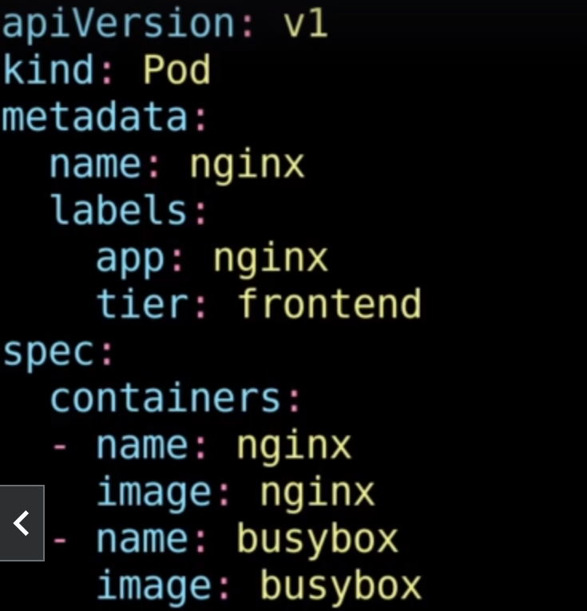

This is the sample YAML specification that could be used by the Kubernetes to create a sample container.